Setelah kita membuat form-form untuk data master maka sekarang kita akan membuat form untuk proses transaksi. Proses yang akan kita catat dalam aplikasi ini ada lima transaksi yaitu :

1. Transaksi pembelian.
2. Transakasi retur pembelian.
3. Transaksi penjualan grosir.
4. Transaksi penjualan eceran.
5. Transaksi retur penjualan.

Kita akan membahas satu per satu semua form-form transaksi tersebut. Yang pertama akan kita buat adalah form pembelian barang. Yang dibutuhkan untuk membuat form pembelian barang adalah :

|  |  |  |
| --- | --- | --- |
| **Object** | **Properties** | **Setting** |
| **Form** | Name | FrmBeliBarang |
|  | BorderStyle | 0-None |
|  | BackColor | &H00FFC0C0& |
|  | StartUpPosition | 2-CenterScreen |
| **Label** | Name | Label1 |
|  | Font | Calibri |
|  | ForeColor | &H8000000D& |
|  | Caption | Form Pembelian Barang |
|  | Name | Label2 |
|  | Font | Calibri |
|  | ForeColor | &H8000000D& |
|  | Caption | No Kwitansi |
|  | Name | Label3 |
|  | Font | Calibri |
|  | ForeColor | &H8000000D& |
|  | Caption | Supplier |
|  | Name | Label4 |
|  | Font | Calibri |
|  | ForeColor | &H8000000D& |
|  | Caption | Tanggal Transaksi |
|  | Name | Label5 |
|  | Font | Calibri |
|  | ForeColor | &H8000000D& |
|  | Caption | TanggalKirim |
|  | Name | Label6 |
|  | Font | Calibri |
|  | ForeColor | &H8000000D& |
|  | Caption | Nama Barang |
|  | Name | Label7 |
|  | Font | Calibri |
|  | ForeColor | &H8000000D& |
|  | Caption | Jumlah |
|  | Name | Label8 |
|  | Font | Calibri |
|  | ForeColor | &H8000000D& |
|  | Caption | Harga Beli |
|  | Name | Label9 |
|  | Font | Calibri |
|  | ForeColor | &H8000000D& |
|  | Caption | Biaya Kirim |
|  | Name | Label10 |
|  | Font | Calibri |
|  | ForeColor | &H8000000D& |
|  | Caption | Jumlah Bayar |
| **Textbox** | Name | TxtKwitansi |
|  | Appearance | 0-Flat |
|  | Height | 330 |
| **TDBDate** | Name | TxtTgl |
|  | DisplyFormat | dd mmmm yyy |
|  | ButtonVisible | 1-True |
|  | Height | 330 |
|  | Name | TxtTglKirim |
|  | DisplyFormat | dd mmmm yyy |
|  | ButtonVisible | 1-True |
|  | Height | 330 |
| **SSOleDBCombo** | Name | CmbSupplier |
|  | Height | 330 |
|  | BackColorOdd | &H00FFC0C0& |
|  | Name | CmbBarang |
|  | Height | 330 |
|  | BackColorOdd | &H00FFC0C0& |
| **TDBNumber** | Name | TxtJumlah |
|  | Height | 330 |
|  | appearance | 0-Flat |
|  | DisplayFormat | ###,###,###,##0.00;(###,###,###,##0.00) |
|  | Format | ###,###,###,##0.00 |
|  | Name | TxtHarga |
|  | Height | 330 |
|  | appearance | 0-Flat |
|  | DisplayFormat | ###,###,###,##0.00;(###,###,###,##0.00) |
|  | Format | ###,###,###,##0.00 |
|  | Name | TxtKirim |
|  | Height | 330 |
|  | appearance | 0-Flat |
|  | DisplayFormat | ###,###,###,##0.00;(###,###,###,##0.00) |
|  | Format | ###,###,###,##0.00 |
| **VBButton** | Name | CmdSave |
|  | ButtonType | 4-Mac |
|  | Caption | &Save |
|  | Name | CmdCancel |
|  | ButtonType | 4-Mac |
|  | Caption | &Cancel |
|  | Name | CmdInput |
|  | ButtonType | 4-Mac |
|  | Caption | &Cari |
|  | Name | vbButton1 |
|  | ButtonType | 3-WindowsXP |
|  | Caption | - |
|  | BackColor | &H00FFC0C0& |
|  | Name | vbButton2 |
|  | ButtonType | 3-WindowsXP |
|  | Caption | X |
|  | BackColor | &H00FFC0C0& |
| **TDBGrid** | Name | Grid |
|  | DeadAreaColor | &H00FFC0C0& |
|  | ColumnFooter | False |
|  | MarqueeStyle | 2-HighlightCell |
| **TDBGrid.** **Column(0)** | DataField | Noket |
|  | Caption | Nomor |
| **TDBGrid.** **Column(1)** | DataField | Kodebarang |
|  | Caption | KodeBarang |
|  | Visible | False |
| **TDBGrid.** **Column(2)** | DataField | NamaBarang |
|  | Caption | Nama Barang |
| **TDBGrid.** **Column(3)** | DataField | Jumlah |
|  | Caption | Jumlah |
| **TDBGrid.** **Column(4)** | DataField | HargaBeli |
|  | Caption | Harga Beli |
| **TDBGrid.** **Column(5)** | DataField | BiayaKirim |
|  | Caption | Biaya Kirim |
| **Adodc** | Name | AdoBarang |
|  | Visible | False |
|  | Name | AdoSupplier |
|  | Visible | False |

Tampilan design form pembelian barang

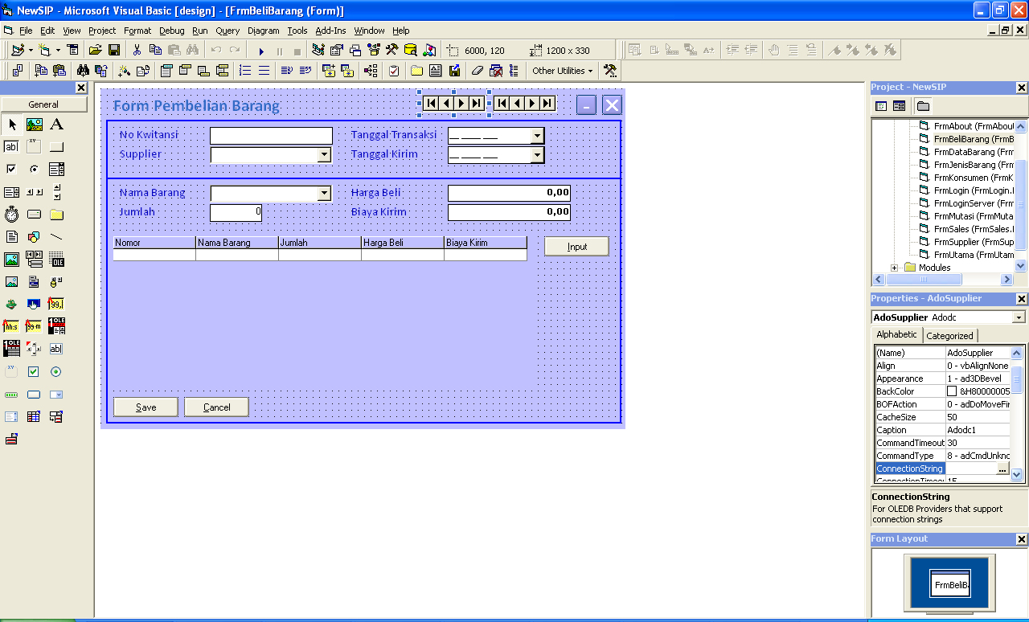

Tampilan form pembelian barang saat dijalankan

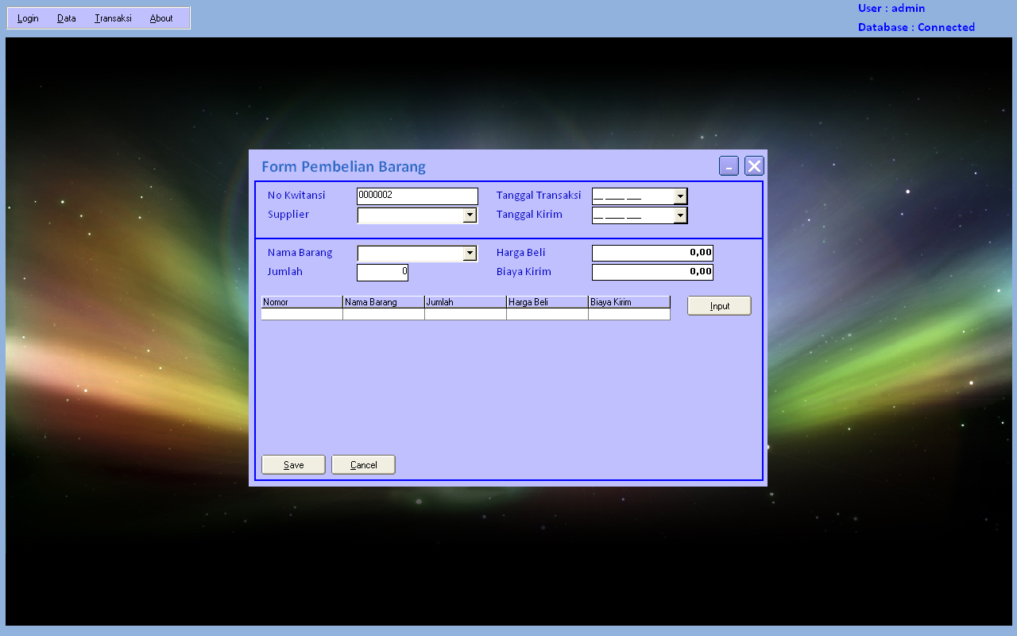

Source code program:

Dim RsTemp2 As New ADODB.Recordset

Private Sub CmbBarang_DropDown()

AdoBarang.RecordSource = ""

SQL = "Select KodeBarang,NamaBarang from Barang order by kodeBarang"

Set RSFind = DbCon.Execute(SQL)

If RSFind.BOF Then Exit Sub

AdoBarang.RecordSource = SQL

AdoBarang.Refresh

With CmbBarang

.DataSourceList = AdoBarang

.DataFieldList = "NamaBarang"

.Columns(0).Visible = False

.Columns(1).Width = 2000

End With

End Sub

Private Sub CmbBarang_GotFocus()

If Trim(CmbSupplier) = "" Or Not CmbSupplier.IsItemInList Then

MsgBox "Supplier Belum Dipilih"

CmbSupplier.SetFocus

Exit Sub

ElseIf TxtTgl = Null Then

MsgBox "Tanggal Beli Kosong"

TxtTgl.SetFocus

Exit Sub

ElseIf TxtTglKirim = Null Then

MsgBox "Tanggal Kosong Kosong"

TxtTglKirim.SetFocus

Exit Sub

End If

End Sub

Private Sub CmbSupplier_DropDown()

AdoSupplier.RecordSource = ""

SQL = "Select KodeSupplier,NamaSupplier from Supplier order by kodeSupplier"

Set RSFind = DbCon.Execute(SQL)

If RSFind.BOF Then Exit Sub

AdoSupplier.RecordSource = SQL

AdoSupplier.Refresh

With CmbSupplier

.DataSourceList = AdoSupplier

.DataFieldList = "NamaSupplier"

.Columns(0).Visible = False

.Columns(1).Width = 2000

End With

End Sub

Private Sub CmdCancel_Click()

Form_Load

End Sub

Private Sub CmdInput_Click()

If Trim(CmbBarang) = "" Or Not CmbBarang.IsItemInList Then

MsgBox "Barang Belum Dipilih"

CmbBarang.SetFocus

Exit Sub

ElseIf TxtJumlah = 0 Then

MsgBox "Jumlah Masih 0"

TxtJumlah.SetFocus

Exit Sub

ElseIf TxtHarga = 0 Then

MsgBox "Harga Beli Masih 0"

TxtHarga.SetFocus

Exit Sub

ElseIf TxtKirim = 0 Then

MsgBox "Biaya Kirim Masih 0"

TxtKirim.SetFocus

Exit Sub

End If

RsTemp2.Find "namaBarang='" & Trim(CmbBarang) & "'", , adSearchForward, 1

If RsTemp2.EOF Then

With RsTemp2

.AddNew

!NoKet = RsTemp2.RecordCount

!namaBarang = Trim(CmbBarang)

!KodeBarang = Trim(CmbBarang.Columns(0).Text)

!Jumlah = Val(TxtJumlah)

!HargaBeli = Val(TxtHarga)

!BiayaKirim = Val(TxtKirim)

.Update

End With

Grid.DataSource = RsTemp2

Grid.Refresh

Else

MsgBox "Barang Sudah Diinputkan."

Exit Sub

End If

CmbBarang = ""

TxtJumlah = 0

TxtHarga = 0

TxtKirim = 0

CmbBarang.SetFocus

End Sub

Private Sub CmdSave_Click()

If RsTemp2.RecordCount = 0 Then

MsgBox "Tidak Ada Barang Dalam List"

Exit Sub

End If

SQL = "insert into BeliBarang values('" & Trim(TxtKwitansi) & "','" & FormatTgl(TxtTgl) & "','" & _

Trim(CmbSupplier) & "','" & FormatTgl(TxtTglKirim) & "')"

DbCon.Execute SQL

RsTemp2.MoveFirst

While Not RsTemp2.EOF

With RsTemp2

SQL = "insert into dtlBeliBarang values('" & Trim(TxtKwitansi) & "','" & FormatTgl(TxtTgl) & _

"','" & !NoKet & "','" & !KodeBarang & "'," & !Jumlah & "," & !HargaBeli & "," & _

!BiayaKirim & ")"

DbCon.Execute SQL

End With

RsTemp2.MoveNext

Wend

MsgBox "Data Saved"

Bersih

TxtKwitansi.SetFocus

Form_Load

End Sub

Private Sub Form_Load()

If RsTemp2.State Then RsTemp2.Close

AdoBarang.ConnectionString = ConDB

AdoSupplier.ConnectionString = ConDB

Bersih

TxtKwitansi = KodeAuto

With RsTemp2

.Fields.Append "NoKet", adInteger, 4

.Fields.Append "KodeBarang", adVarChar, 50

.Fields.Append "NamaBarang", adVarChar, 50

.Fields.Append "Jumlah", adInteger, 4

.Fields.Append "HargaBeli", adDouble, 8

.Fields.Append "BiayaKirim", adDouble, 8

.Open

End With

End Sub

Sub Bersih()

CmbSupplier = ""

TxtTgl = Null

TxtTglKirim = Null

CmbBarang = ""

TxtJumlah = 0

TxtHarga = 0

TxtKirim = 0

End Sub

Private Sub TxtHarga_GotFocus()

CmbBarang_GotFocus

End Sub

Private Sub TxtJumlah_GotFocus()

CmbBarang_GotFocus

End Sub

Private Sub TxtKirim_GotFocus()

CmbBarang_GotFocus

End Sub

Private Sub vbButton1_Click()

Me.WindowState = vbMinimized

End Sub

Private Sub vbButton2_Click()

Unload Me

End Sub

Function KodeAuto()

'SQL = "Select No_Urut from ServiceMobil order by No_Urut"

'Set RSFind = DbCon.Execute(SQL)

'If Not RSFind.BOF Then

' KodeAuto = RSFind!no_urut

' Exit Function

'End If

SQL = "Select KodeTransaksi from BeliBarang order by KodeTransaksi Desc"

Set RSFind = DbCon.Execute(SQL)

If RSFind.BOF Then

KodeAuto = "0000001"

Else

KodeAuto = Format(CInt(Left(RSFind!KodeTransaksi, 7)) + 1, "0000000")

End If

End Function